1. Unrouted/Unrouteable Messages: The messages which can’t be route from an exchange to a queue.
2. 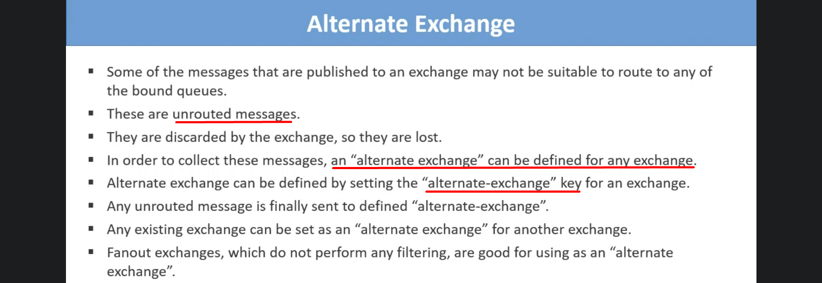
3. 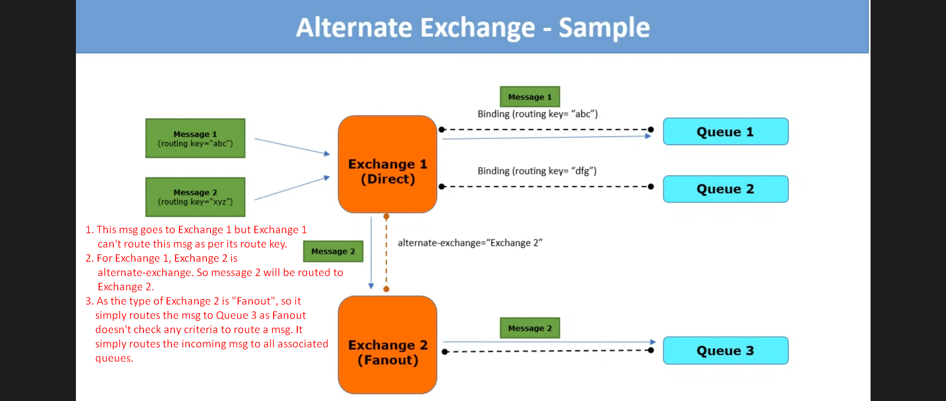
4. Such messages which couldn’t be routed to a queue can be analysed later on.